Integrate Jenkins with docker

First we need to install docker in our linux machine

1. “sudo apt update”
2. “sudo apt install docker.io”
3. “sudo systemctl start docker” and check status “sudo systemctl status docker”

It will show like that

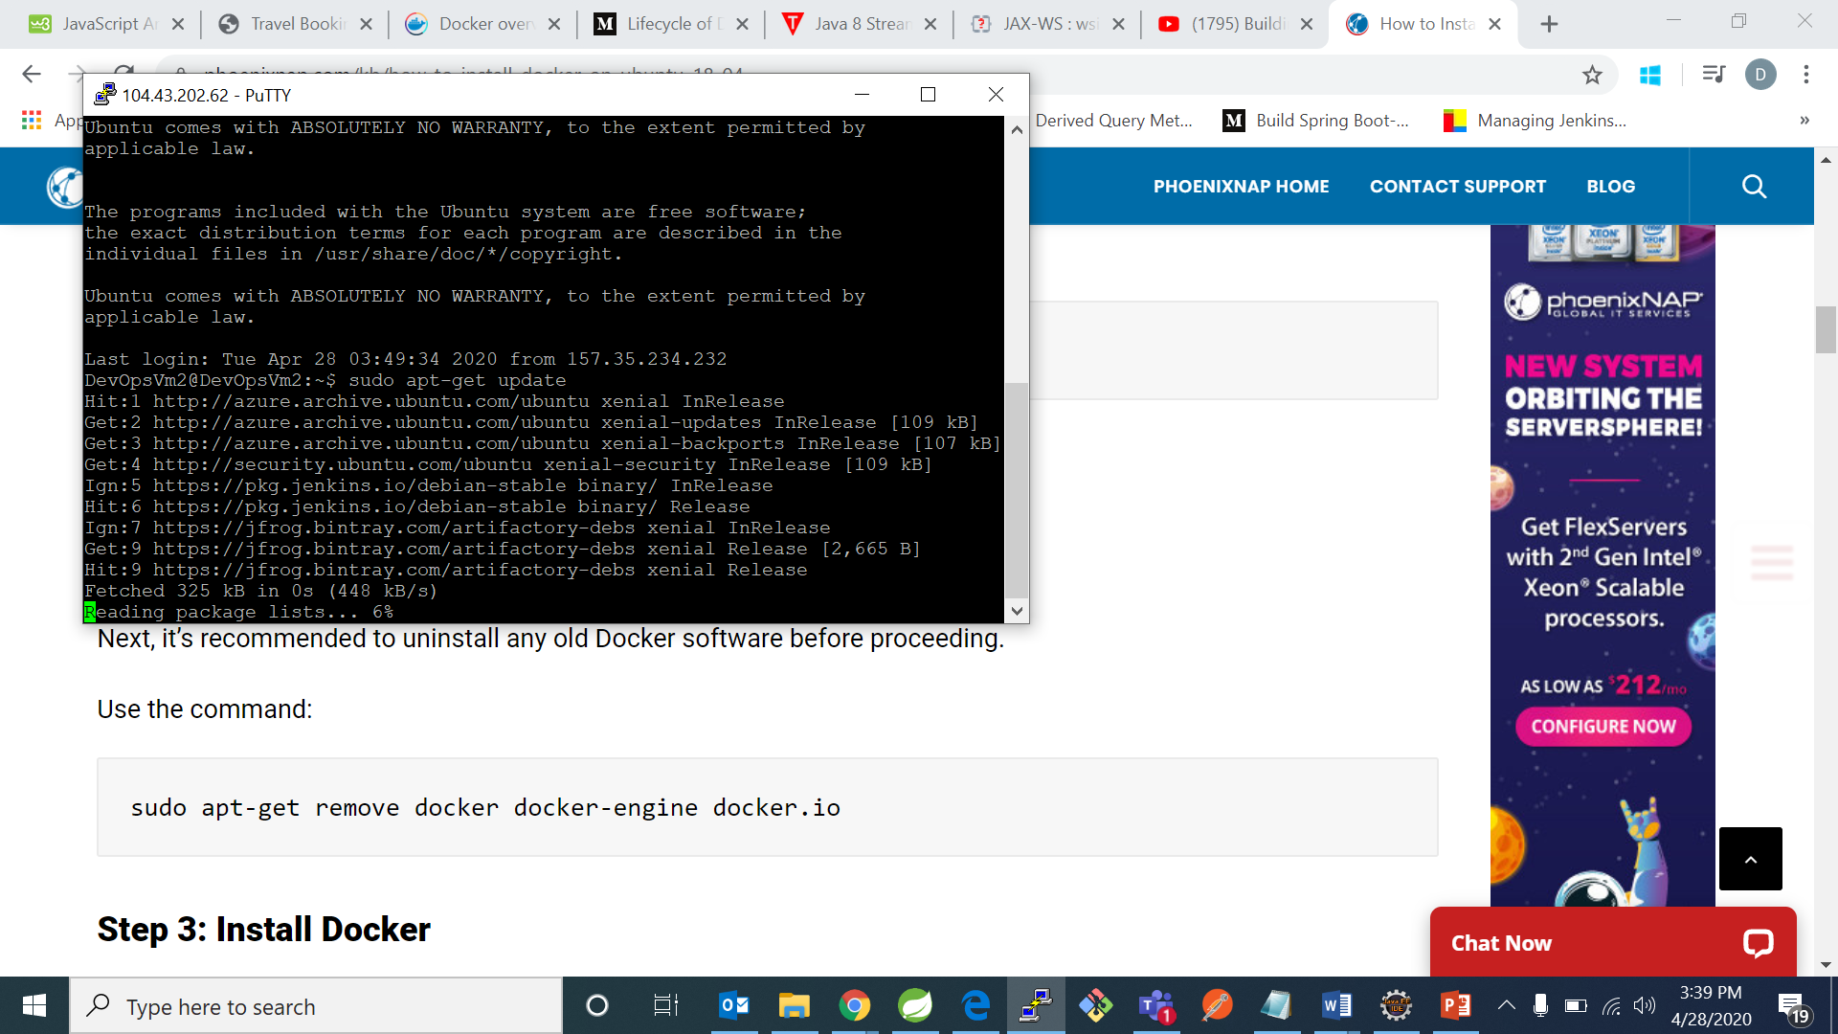

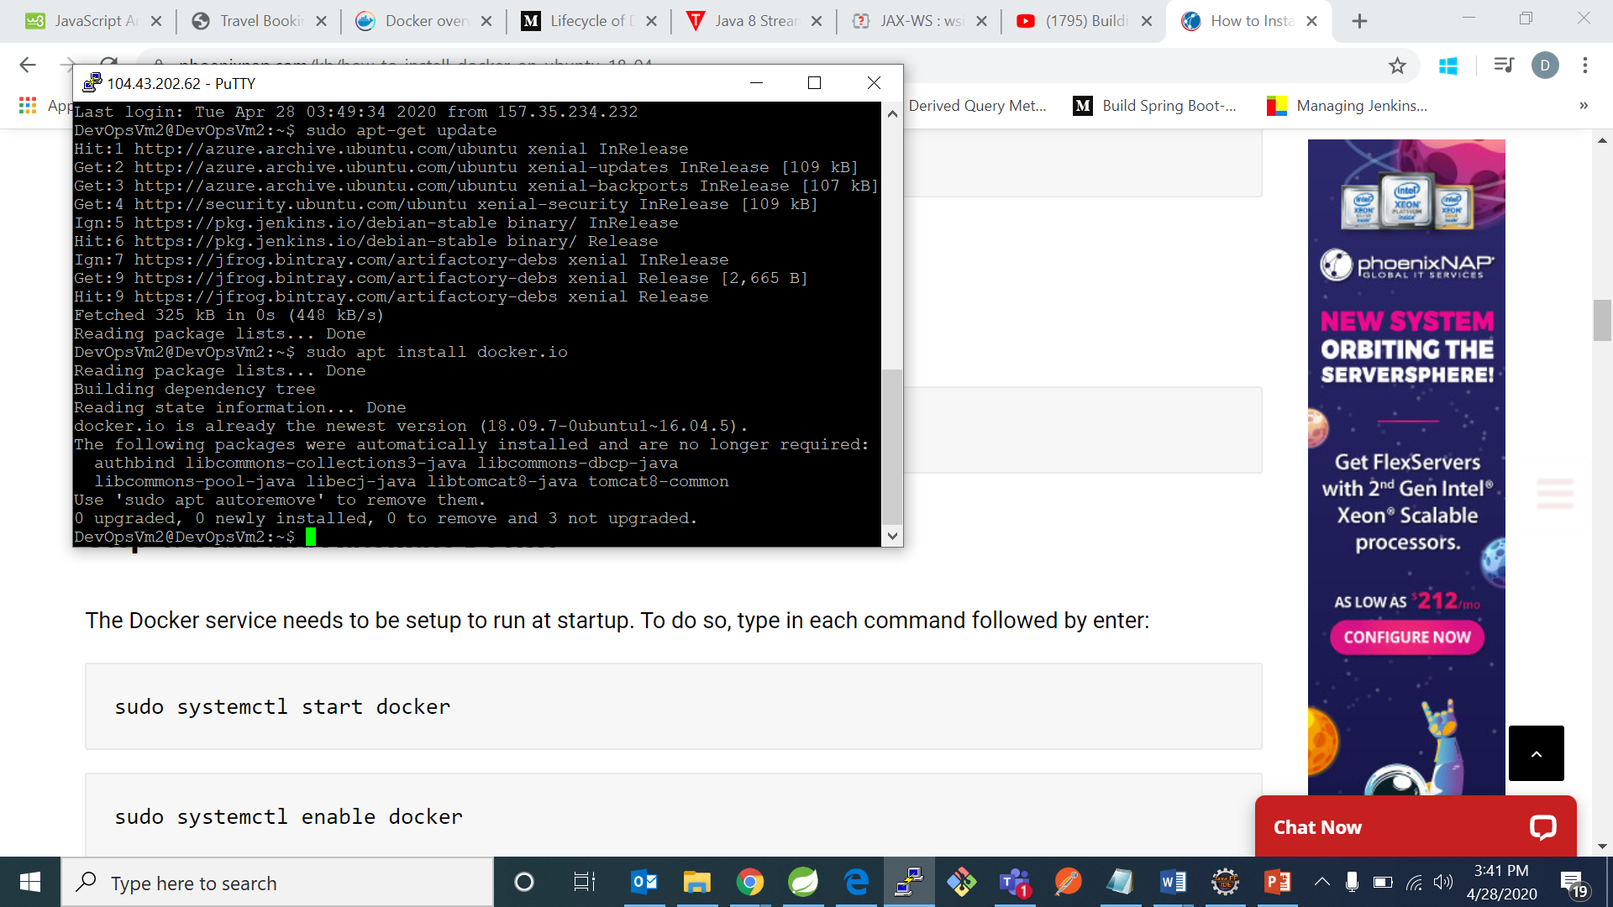

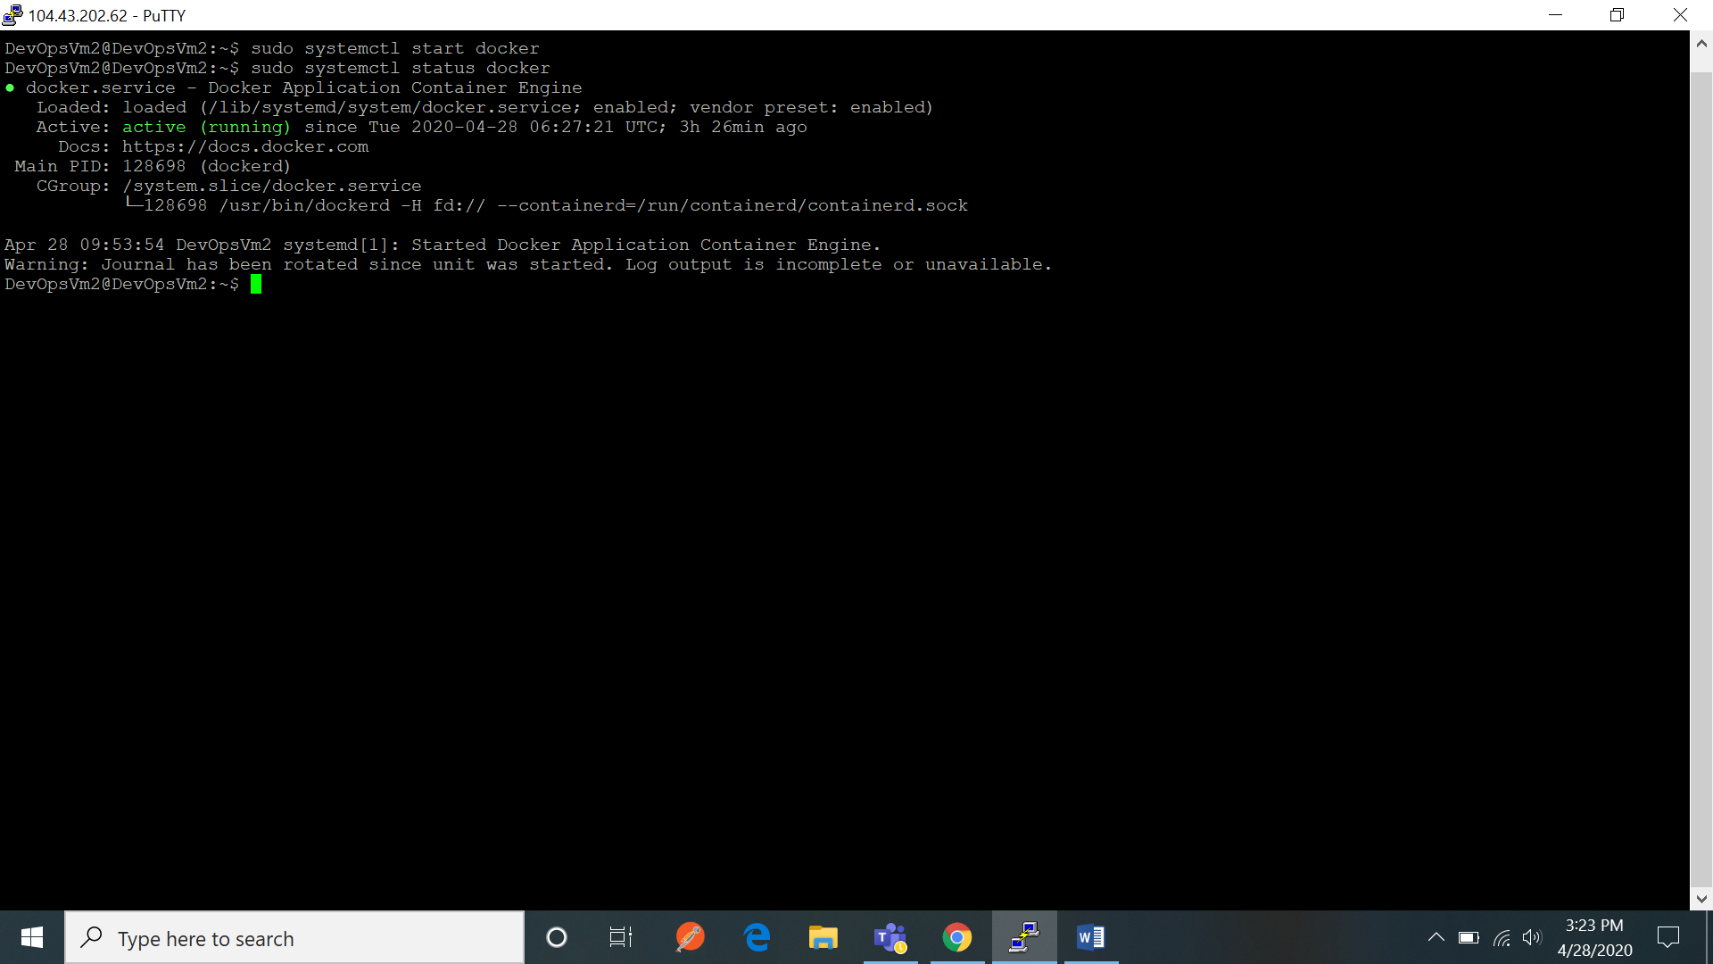

* After that give read write permission to docker.sock which is present in /var/run/docker.sock by running command :

“sudo chmod 666 /var/run/docker.sock”

Now to install SonarQube using docker:

1. Dowload the sonarqube from LTS .For the latest version of sonarqube from docker use command :

“docker pull library/sonarqube:lts”

“docker pull library/sonarqube:latest”

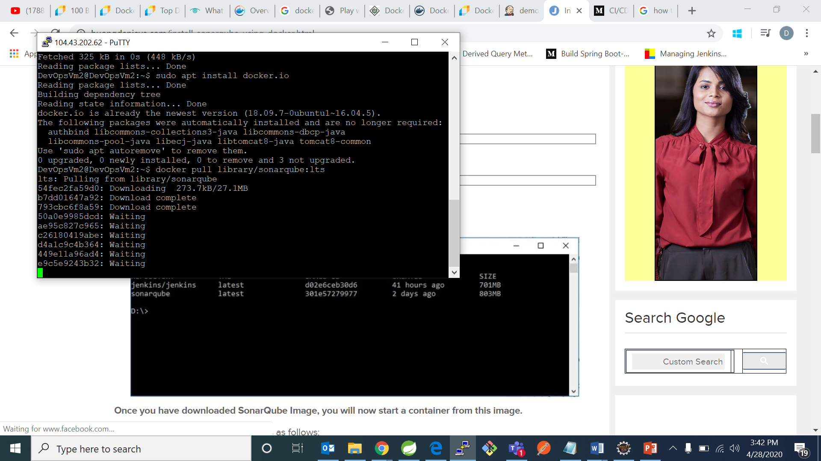

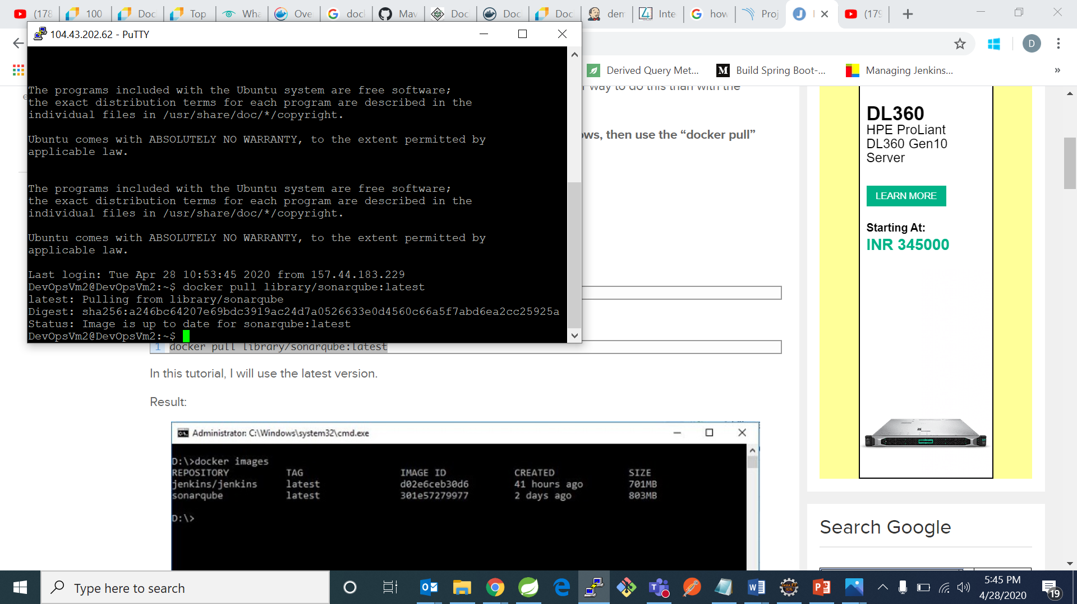

1. Now after downloading sonarqube now start container:

“docker run -d -p 9000:9000 sonarqube”

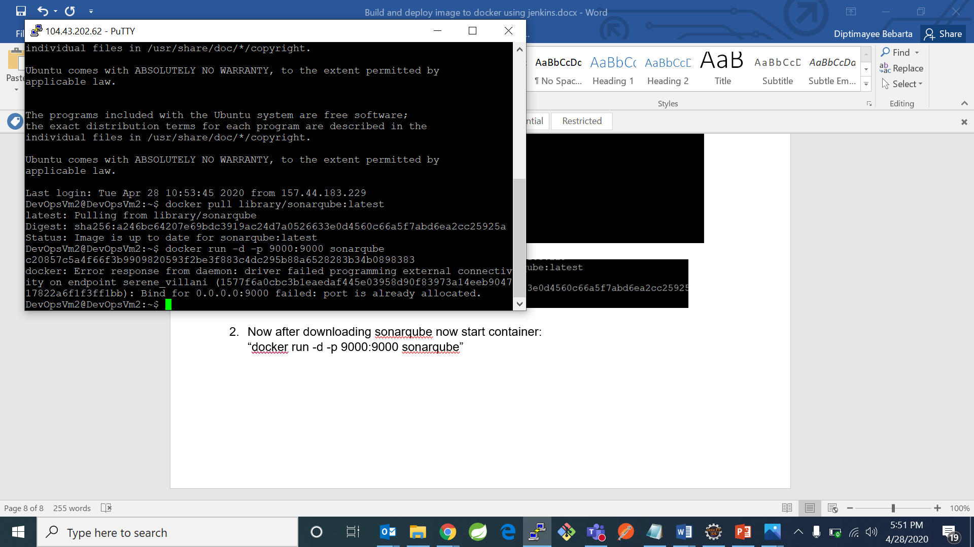

Now open your sonarqube on 9000 port

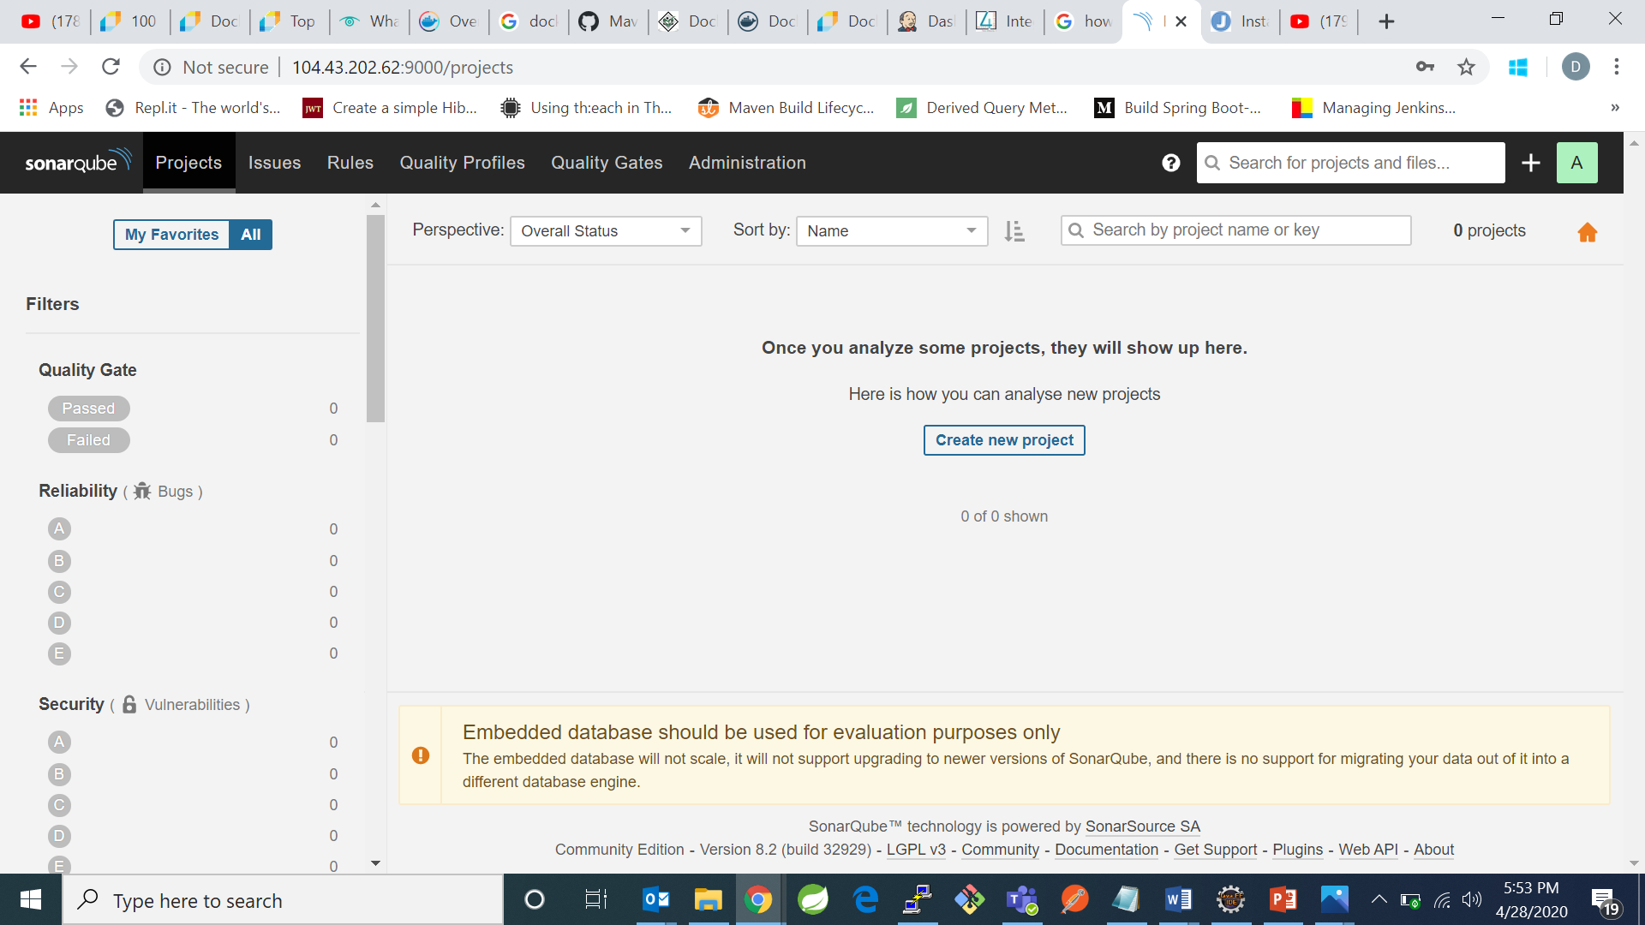

* Now go to jenkins and click on manage jenkins and click on manage plugins and search for a plugins called

1. Docker plugin
2. Cloudbess docker plugin
3. Docker build-step plugin

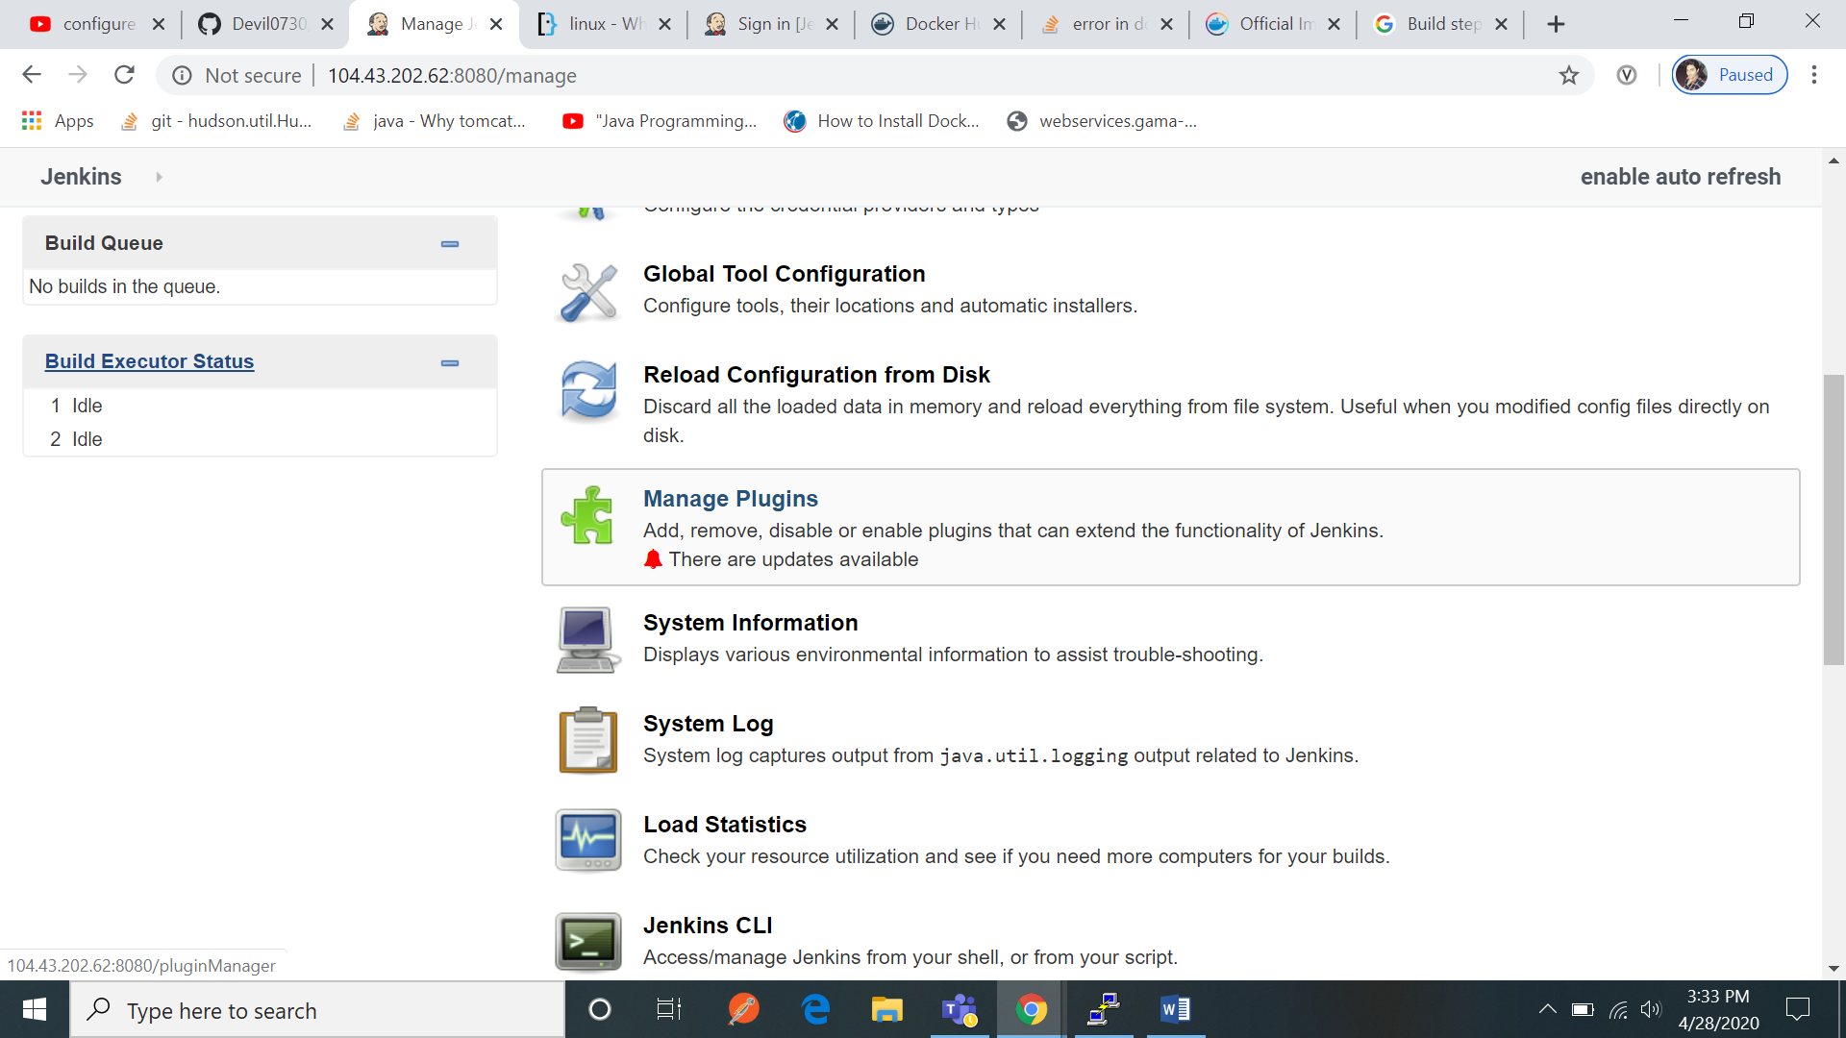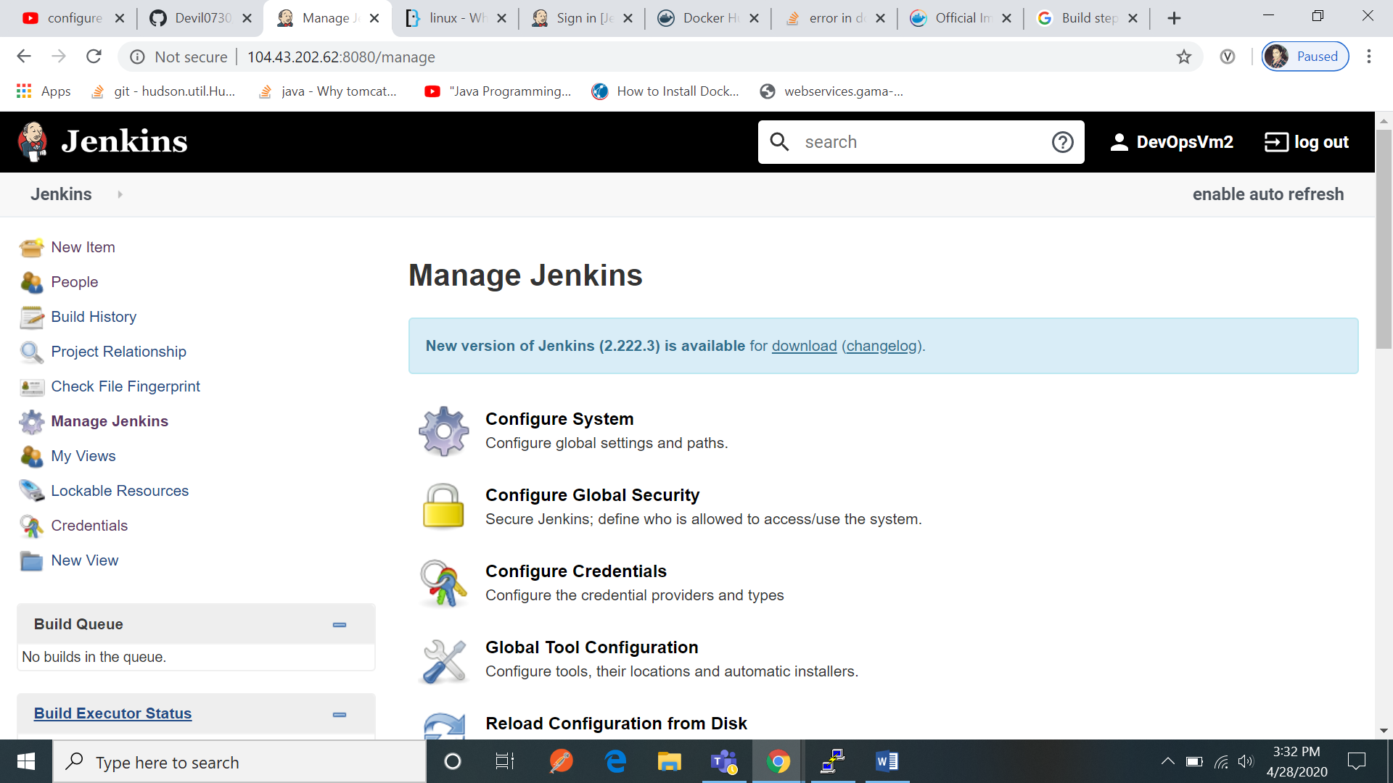

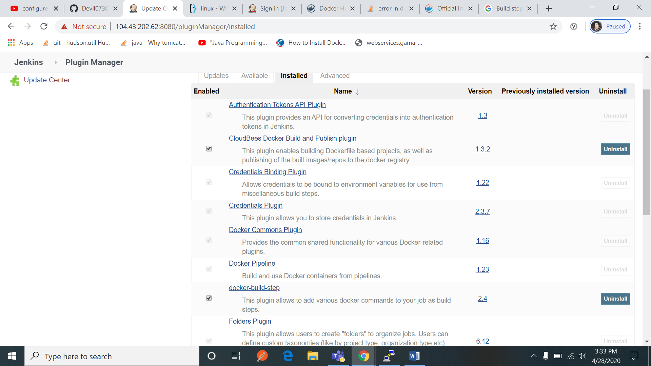

After that click on jenkins home and click on new item and select freestyle project and then provide git hub link and in source management tab check on git and there also paste url of your github after that go to build tab and click on “invoke top level maven targets”

And in goals write install and also select something called as “docker build and publish”

And go to your git hub account and create Docker file and type as below shown

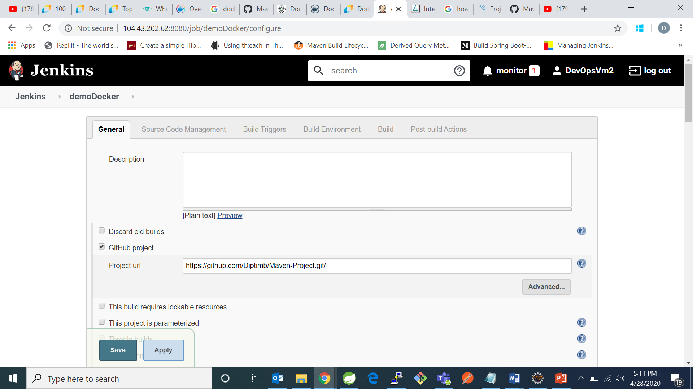

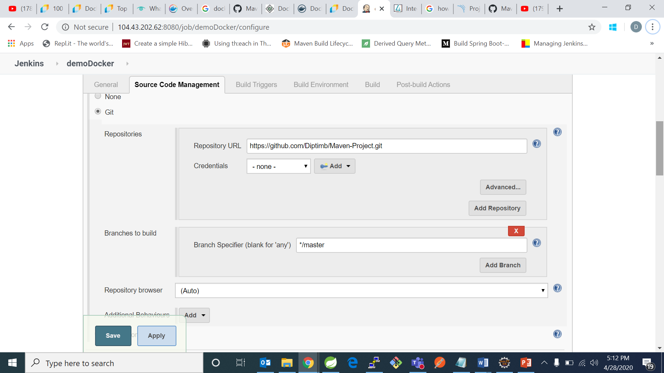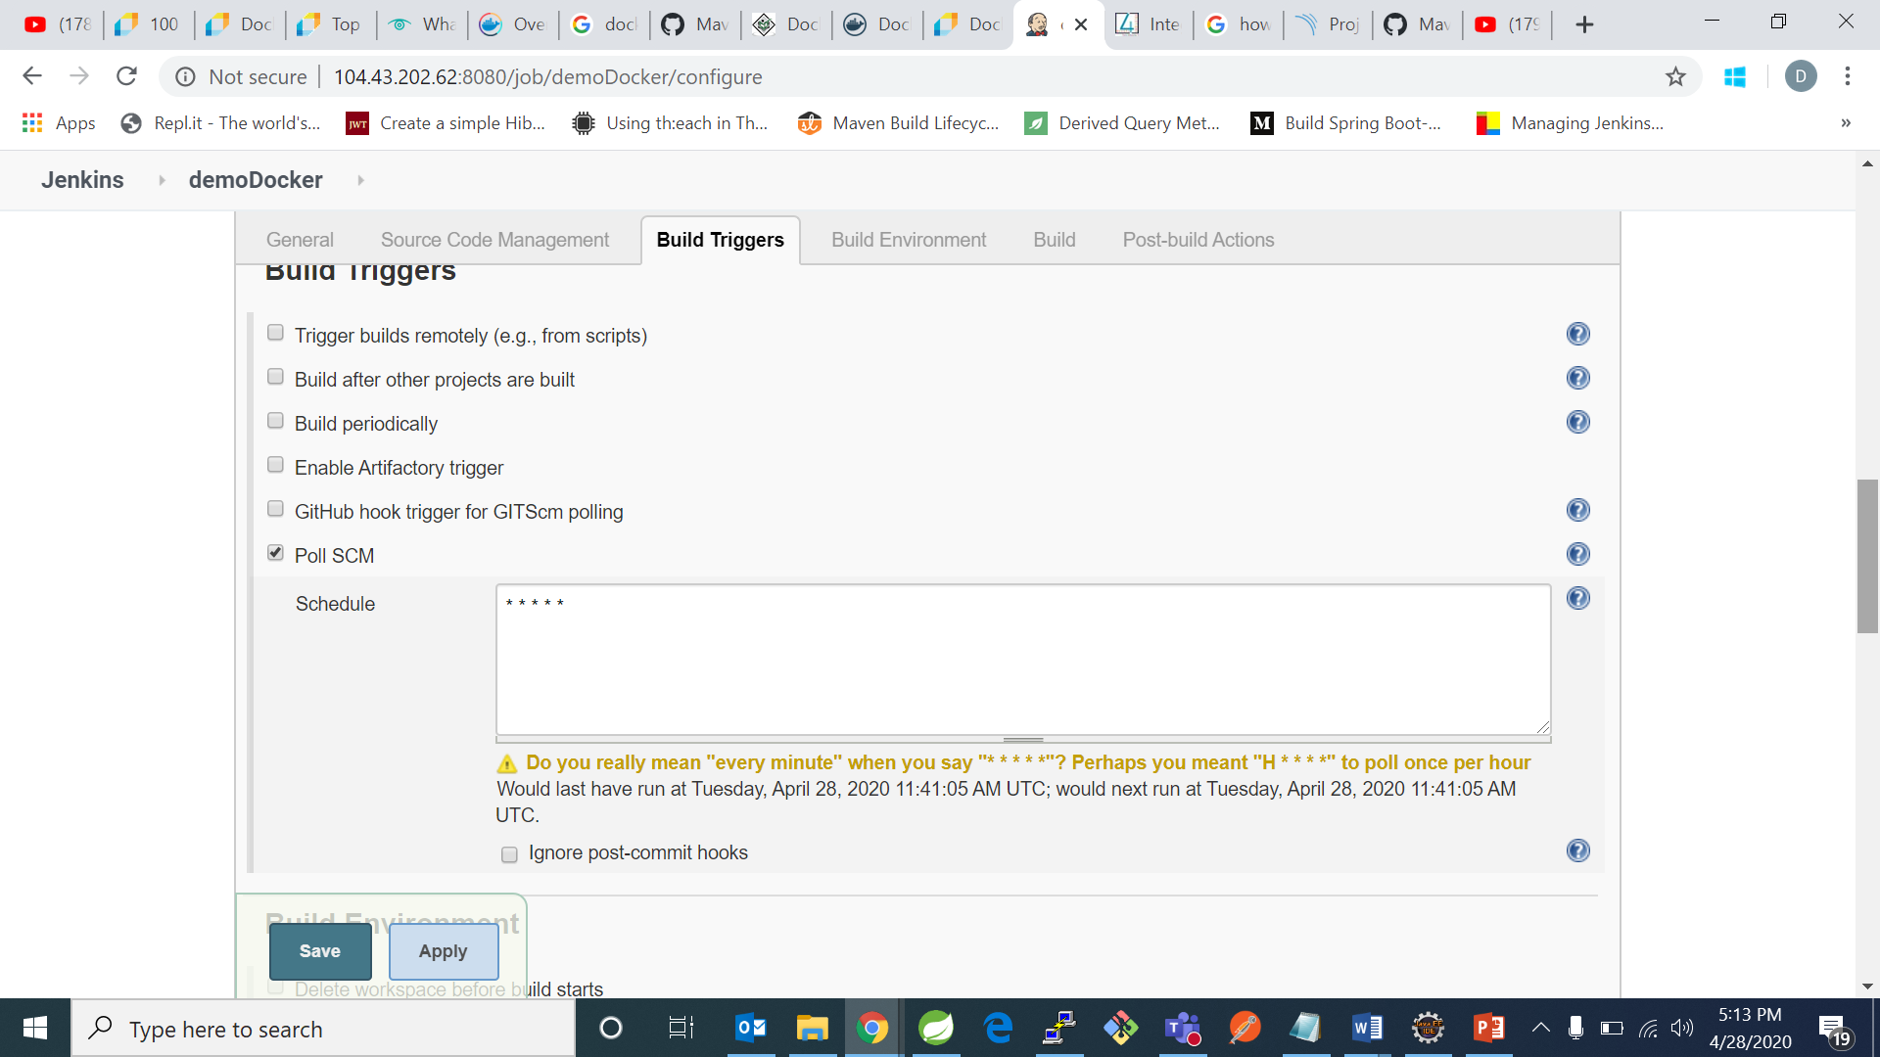

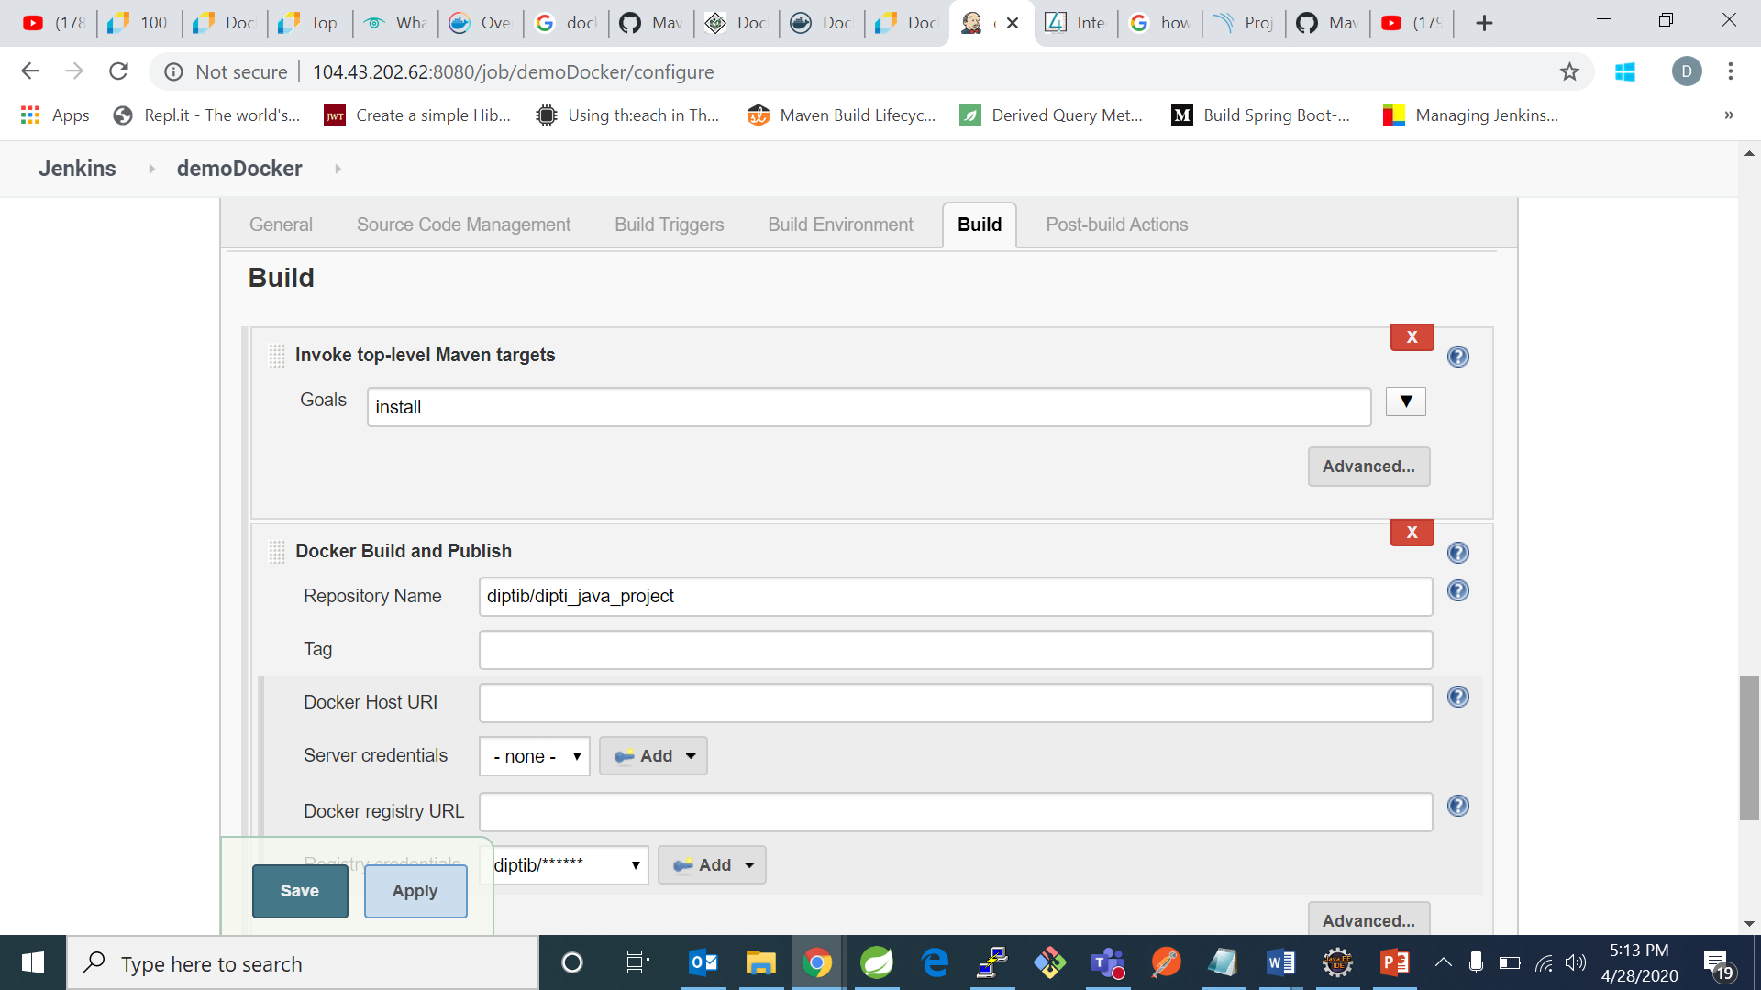

And click on save.

Now open your github project repository and create a dockerfile-“Dockerfile” with the following contents:

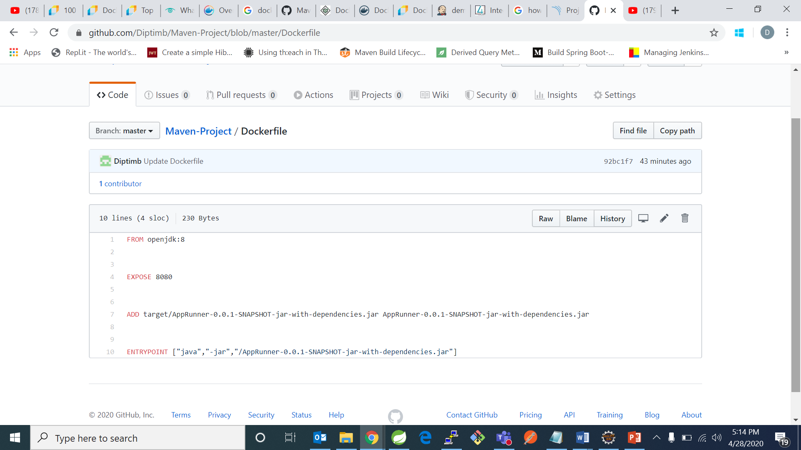

After that go back to your jenkins and click on build now and u will see you console like this

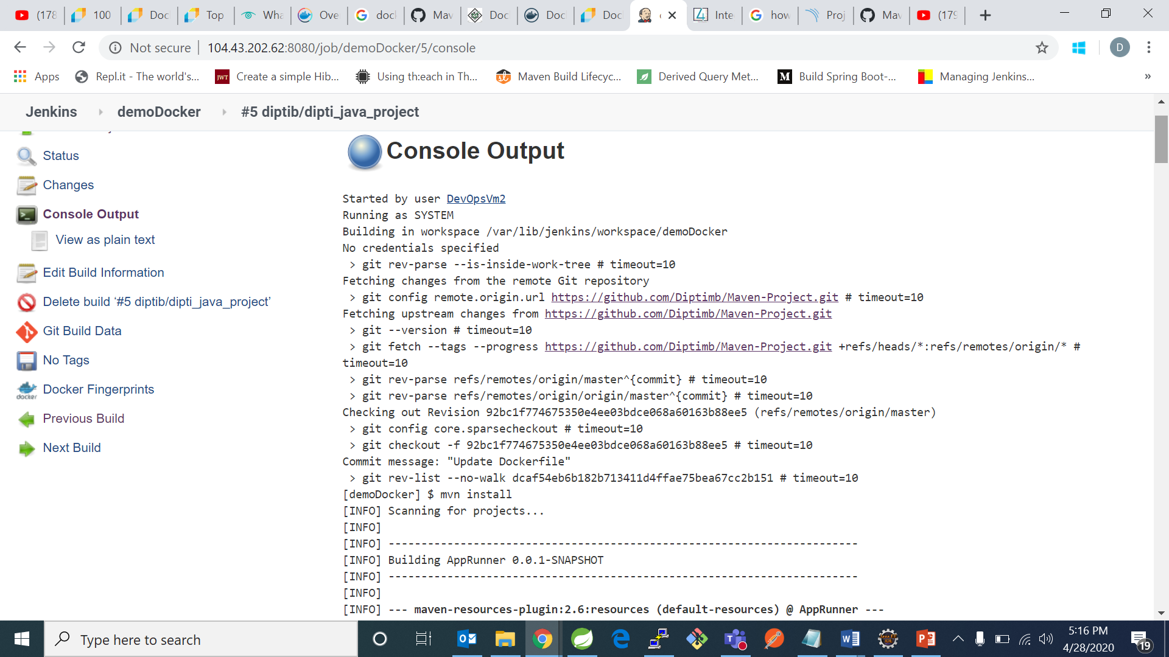

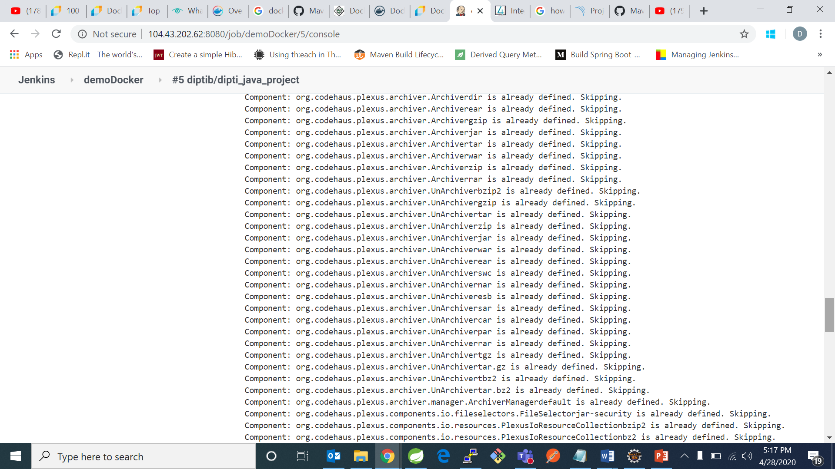

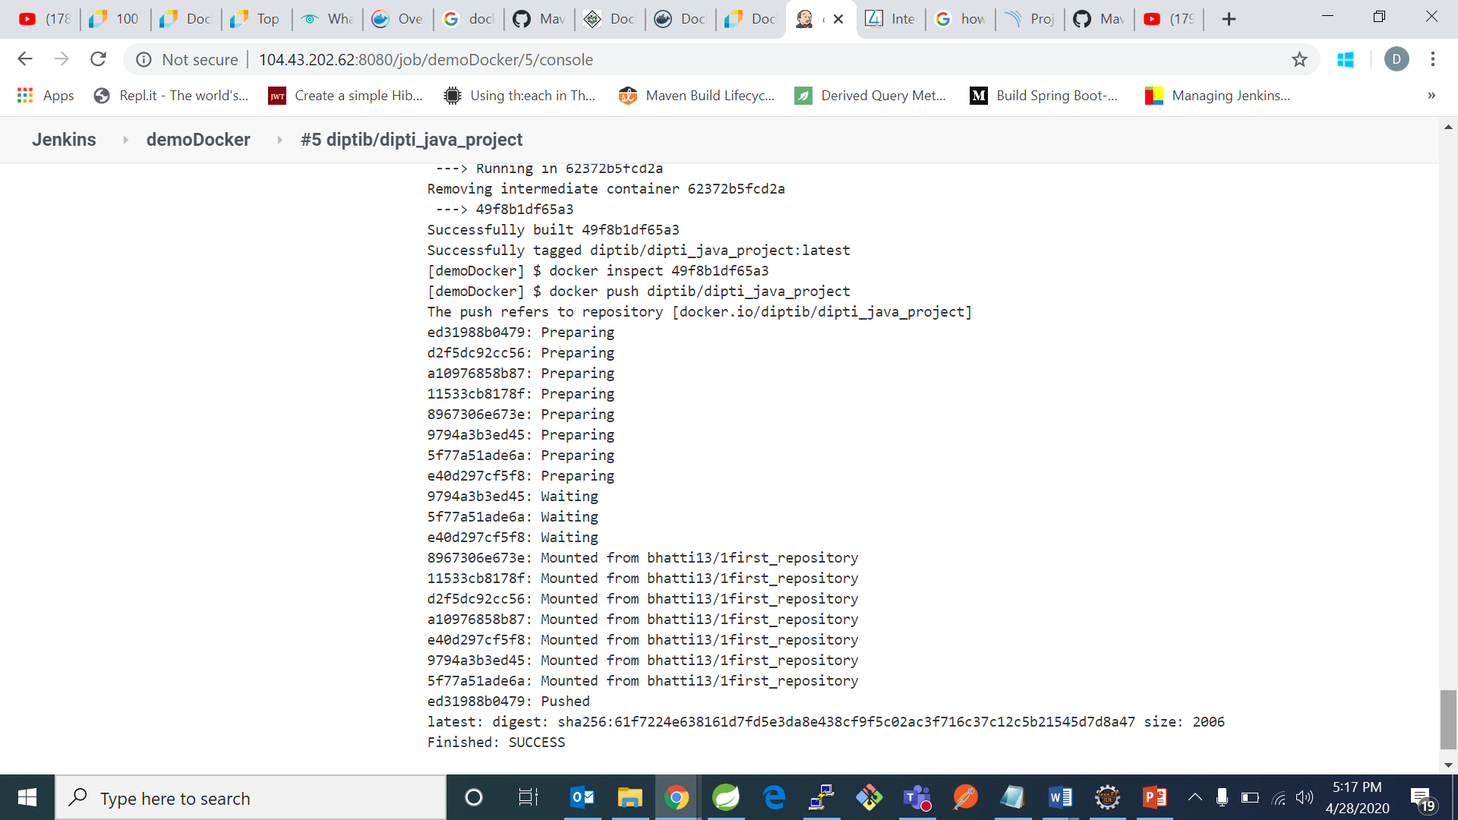

We can go to docker hub and check for our deploy: 